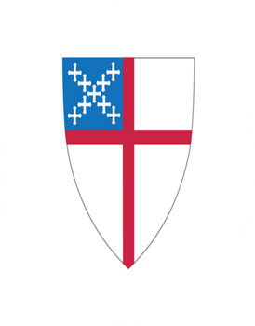
Autumn Newsletter
Holy Cross Episcopal Church
4603 Rocks Road (Route 24), Street, MD 21154
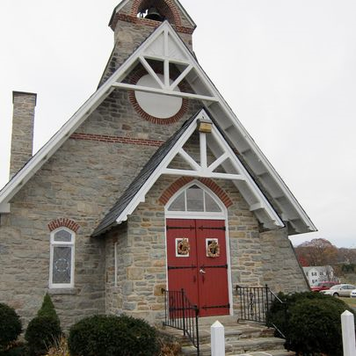
Holy Cross Church, P.O. Box 103, Street, MD 21154

St Francis Day at Holy Cross: Blessing of the Animals

Sunday October 6 at 9:30 a.m. Holy Cross welcomes you and your pet to our service! Weather
permitting the service will be outdoors on the parking lot; rain space is the parish hall. St.
Francis loved the animals, who – so the stories go- also loved him and his preaching! He also
loved all human animals too, in fact he particularly loved any living creature who was little, lost,
vulnerable. So we try to capture something of both in our own celebration – blessing the
animals, and also helping households who may not be able to feed their animals. Bring your
pets (appropriately leashed/ contained, or whatever) and also bring a contribution of pet food for
the Mason Dixon Community center! You may also bring photos of pets who don’t travel well or
appreciate a crowd. Giovanni di Pietro di Bernardone (c. 1181 – 3 October 1226), known as
Francis of Assisi, was an Italian mystic, poet, preacher, “good trouble maker”, who gathered
together all who would listen to God’s message of Love for all of Creation (even when that was
inconvenient or troublesome for the “authorities.) Did you know he was also the first to introduce
the Christmas Creche or Nativity scene as a way of celebrating Christmas? Come celebrate and bring a friend or neighbor!

A note from Rev. Jan
“May each student, each teacher, and each one who works be blessed this year! May our work
glorify you, O God.” When we offered our Backpack Blessings at a summer Sunday, school had
started for some, and was about to start for others. Each one present- adults and younger ones-
picked out a notebook with some questions to ponder each day. When was I kind? When was I
a helper? When was I mean today? I give thanks for: I am worried about: I am sorry about:
Instructions: pick one or more questions each day to answer in words or pictures. This is a
simple way to remind ourselves that we are in God’s presence always, and a way to review or
examine our day with God. The initial 10 notebooks were all gone by the end of the morning.
Another 10 are now at church in the pass-way ledge between parish hall and the sanctuary.
Please let me know if you want one and didn’t get one! Staples may let me get another 10 at a
third visit. Rev. Jan

A note from Rev. Mary
Want a deeper connection with the wider Church and community? Try some of these:
*Volunteer with one of the ministries which Holy Cross supports (see Parish Hall poster).
*Pray for Walter and Emma Scarborough preparing for confirmation. Come support them on
November 10, and bring your friends! Ask Theresa Freligh how you can help welcome Bishop
Carrie Schofield-Broadbent.
*Pray for diocesan canons and staff (https://episcopalmaryland.org/staff/), exploring new ways
of working together under Bishop Carrie’s leadership.
*Give thanks for those who have visited Holy Cross: Canon Christine McCloud supplied in July 2023; Canon Kristofer Lindh-Payne facilitated last fall’s Mutual Ministry Review and returned in Lent to lead a study session. And Canon Kristin Krantz facilitated our August 2024 Mutual Ministry Review! We celebrated STRENGTHS: care for one another, collaborative and generous outreach, the Strawberry
Festival, Bible Study, and more. HOPES include increased regional connections, documenting
how we do things, inviting more seniors to lunch, inviting and retaining more worshipers.
Canon Kristin described one model: GATHER (=invite, greet, orient, incorporate); TRANSFORM;
SEND; know your CONTEXT.
*Ask Carol Mullins or Theresa about “Becoming Beloved Community,” which they attended
recently. Ask Theresa how she was welcomed when she delivered Holy Cross’s cookies to the
North Harford Elementary faculty—an innovation inspired by the diocesan Vestry Vitality Day,
attended by Sue Becraft, Cathy Steuart, and Mary Davisson+.
*Thank Carol for decades of service as Diocesan Convention delegate, Harford County Regional
Council delegate, and Regional Council treasurer. Harford County Episcopal clergy have been
meeting to plan the next Regional Council meeting on September 23, Holy Trinity Churchville, 7
PM. Only delegates may vote, but all are welcome! –Rev. Mary

Cookies for Teachers
Holy Cross Episcopal Church, The Rocks, is trying something different this year. We want to show our appreciation and respect for the teachers who work tirelessly for the benefit of our youth. We thought that by sending them an array of homemade goodies might be a good start. We delivered a basket full of cookies made by our members to say Thank You to the teachers for all they do. They were extremely grateful for our generosity. If you would like to Thank you for your continued support of our church community.

Senior Warden’s Notes

2 Corinthians 9:8
And God is able to make all grace abound to you, so that having all sufficiency in all things at all times, you may abound in every good work.
It’s amazing that two years has gone by since our Vicar Transition occurred. Another contract addendum is in the works for our Co-Vicars for another year. The Advisory Board and Rev Mary and Rev Jan will be participating in another Mutual Ministry Review that will be led by Rev Kristin Krantz - Canon for Transitions | Director, The College for Congregational Development on August 28th.
We will open the Review with a prayer, and we shall all offer to share our concerns and expectations. This was offered by the Dioceses as a tool to look at the challenges and conflicts we face with a change in parish leadership. Relationships work better when people articulate their expectations instead of assuming. The successful programs and outreach we do in our community will continue with our support. Your support of the Grocery Bag Sundays has been phenomenal! Sunday School and Senior Lunch programs begin next month. School Supplies and book bag donations again were very generous this year.
Busy times are ahead for Holy Cross with the coming of the Thanksgiving, Advent and Christmas holidays.
Thank you to all involved with keeping our grounds attractive, our building operational, and our spiritual wellness growing and expanding. Many thanks for ALL you do with your time, talent, and treasures. Thank you, Jan and Mary, for your continued spirit and leadership.
May God bless Holy Cross at the Rocks.
Chip

Seafarers “Christmas at Sea” Bags
We will begin collecting items for seafarers the whole month of October. The list of items will be posted on the bulletin board in the parish hall at the end of September. Please sign up. Your support is greatly appreciated. Patty Wilson
Sunday School
This year Sunday School will begin on September 8 th leaving the service during the opening hymn and returning during communion. This year Lucy enters Kindergarten, Charlie, First Grade, and Madelyn, second with our visiting Grandchildren ranging from PreK to Third grade. That said, this year we will try to follow the Episcopal lesson plans that follow the liturgy. Reverend Jan helped kick off the new school year with our traditional Blessing of the Book Bags and Teachers following the service Sunday the 18th blessing our students and teachers and gifting them a journal with thought provoking statements as options for journalling. Cathy Stuart
ANYONE wishing to bring a friend or visiting family is welcome. I’ve learned how to be very flexible. Thank you for your continued support of the Sunday School.
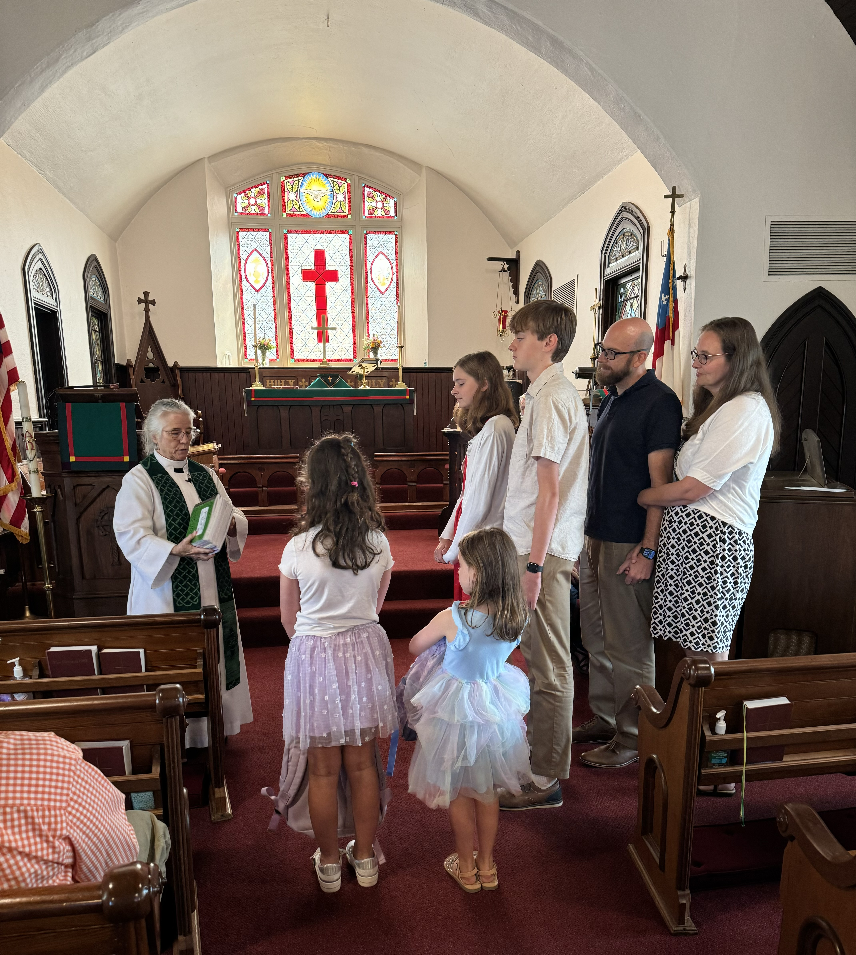

Guild
The Guild met July 21st, 2024. The budget was reviewed with the only change being the cost for our Senior Lunch. Formerly Harford Community Action Agency’s food pantry reimbursed Holy Cross up to $100. We were notified this spring they could no longer support that mission. The senior lunch cost averages $125/month for 10 months equaling $1,250. This year we will begin our luncheon with chicken donated by Mason Dixon and cooked by Holy Cross. The chicken and leftover turkey to be used later in the year will divert some of the cost. The Guild overwhelmingly supported the cost of the luncheon. Going forward, if needed, we will cut the $240. donated to Harford Community Action Agency from our budget. The total financial support made by Holy Cross for 2024 was $8,480. The balance on hand after donations were sent and deposits were posted was $14,426. (July 31,2024). The budget is only one part of the outreach of Holy Cross. School Supply collection, Grocery Bag Sunday, Christmas Adoptions and March Madness Spring Cleaning collection are all in support of Mason Dixon Community Service. Additionally, two weeks ago a few people initiated another Sharing the Thanks by initiating a collection of homemade cookies that will be deliver to North Harford Elementary School for our teachers as they start their year. We expect this to become an annual outreach.
Also, we decided to restart serving dinner at Harford Family House’s Welcome One and will walk in the Walk a Mile in Her Shoes, a fundraiser for SARC Harford County (Sexual Assault Response Coordinators).
The next Guild meeting is scheduled for September 22nd where we will review our fall programs (College and Military Boxes, Family and Senior Christmas giving, Green Sale, Church care/decorating). Cathy Stuart

College and Military Christmas Boxes

The gathering of Christmas Gifts for our College Students and Military Personnel Christmas Boxes is right around the corner. In October, Mary Raab will be requesting the names and addresses,( along with any allergies) of our College Students and Military Personnel. Box assembly will be Thanksgiving week, about November 24 and mailing the boxes via Postal Solutions on the 27th. Sign up will be posted to remind church members the items needed and the total number of packages to be mailed. The box will include a Holy Cross Blessing, plus the Day to Day prayer book, and the following donations to the boxes:
- Candy
- Chocolate (it's own food group)
- Ramen Noodles
- Beef Sticks
- Snacky food like Nutella spreads and Energy bars
- Hot Chocolate and Tea and
- Throat Lozenges. We are looking to see if the gloves and crazy socks are still fun as we have received mixed reviews. Sue Becraft

Calendar
September 16 Senior Lunch
October 6 at 9:30 a.m.– St. Francis Day
October 21 Senior Lunch
November 10 at 9:30 a.m. – Bishop Carrie’s Visit for Homecoming and Confirmation
November 18 Senior Lunch
December 1 at 9:30 a.m.- First Sunday of Advent
December 7 Green Sales
December 24 (Tuesday) at 5:00 pm – Christmas Eve service


