Spring-Summer Newsletter 2024
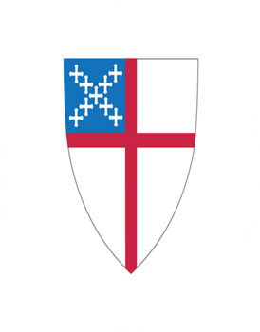
Holy Cross Episcopal Church
4603 Rocks Road (Route 24), Street, MD 21154
Holy Cross Church, P.O. Box 103, Street, MD 21154
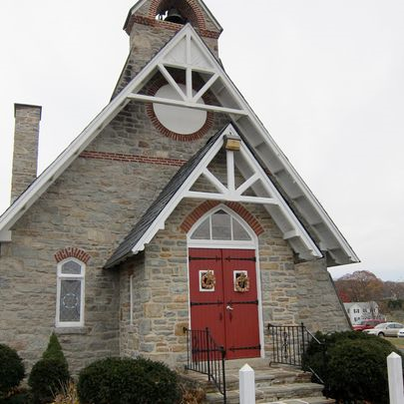

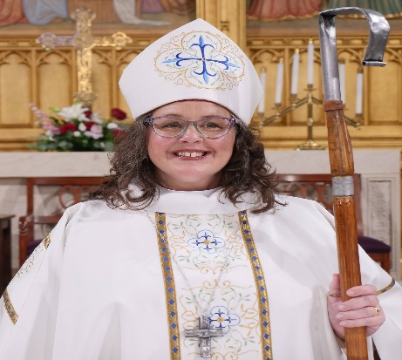

Bishop Carrie Schofield-Broadbent

A Note from Rev. Mary
Thanks for what has been done, grants for our work to come!
“Liturgy” means “work of the people.” Many hands lightened the work of our Lent and Easter.
Some of you came to my rescue when I showed up for Ashes to Go, discovered that the church
had lost power and didn’t know who to call. You shared about your personal experience during
our Lenten study of the cross and our Maundy Thursday conversation, just as generously as
you’d shared during our Advent series on prayer. When I remembered my port chaplain days--
how grateful crews were for onboard ashes in early Lent and palms during Holy Week, how one
seafarer emerged in tears from the church where I’d transported him for Stations of the Cross
because it was his first Holy Week service in seven years—I realized how privileged we are to
share work and worship. And then, what a joy to wave our white streamers together during
every Alleluia on Easter morning!
Preparing our worship space for the many services of Lent and Easter was both work and a
blessing. So is less visible service: producing bulletins, engaging our children in this holy season,
caring for our building, feeding Sunday worshipers and Monday seniors, collecting and
delivering donations for Green Envelopes and Clean Sweep, playing “Easter bunny,” and more.
Thank you, thank you, thank you!
I’m also grateful to those who attended Bishop Carrie’s listening sessions and Vestry Vitality
Day, and I’m looking forward to how these will bear fruit. Rev. Jan will be writing more about
our region and our diocese. Here, I’ll just mention that diocesan grants exist for congregations
or regions beginning new outreach, or taking an existing program to a new level. Information is
at https://episcopalmaryland.org/grants/, and the next deadline will probably be March 2025. I
serve on that committee, so please ask me for more information! –Rev. Mary Davisson

A Note from Rev. Jan

Bishop Diocesan – check our bulletin cover back!
Something new is on the back of our bulletin cover! As of Saturday April 27, we have a new
Diocesan Bishop, a new person in charge. Perhaps you can be at the Cathedral on Saturday
for the 11 a.m. service, or perhaps watch it live-stream at home or watch party at St Mary’s,
Emmorton. Or maybe you will notice the time at 11 and lift a prayer as our Diocesan Bishop
Eugene T Sutton officially retires by handing the crozier (that big shepherd’s crook) to Bishop
Carrie Schofield-Broadbent. At that point, she is officially our Bishop Diocesan -, Bishop Carrie,
bishop number 1160 in Apostolic Succession in the Episcopal Church and Fifteenth Bishop of
Maryland.
We met her over a year ago, with her election in March. She began work on our Diocesan staff
July 1, and was consecrated as a Bishop in September. She and Bishop Sutton have worked
closely together in this transition year. And now she’s in charge. Well, not really because of
course Jesus is really in charge of this Body of Christ, the Church.
There is an old song “Dry Bones” or “Dem Bones” or “head-bone connected to the neck bone
etc etc.” This old spiritual is based on that wonderful vision from the Prophet Ezekiel of the
resurrection not just of bones but also muscles and flesh from the valley dry bones. All the
parts connect to make a living thing – in Ezekiel’s case a new Israel in 6th Century BC. This
important and graphic story passed down through the centuries in both the Jewish tradition and
Christian traditions to remind us that God is the One who gives breath and life. I think St. Paul
had this very story in mind when he wrote the letter to the fractured and fractious Corinthians,
reminding them that every part of the body is important to make up the whole. And perhaps that
story even influenced the activity song/ dance “Head and Shoulders, Knees and Toes,” among
others. Long story short: we are all connected, and specifically as people of God in the Body of
Christ, the Church.
A Diocese, a collection of congregations, is the smallest unit of mission in our Anglican
Tradition. No one congregation can truly function to the best of our ability without the others in
our Diocese. No Region can function without its member congregations, and no congregation
can truly function best without each member, just as our own bodies function best when all our
parts work together. In the Church, the Bishop is the one who calls us together to be the best
showing of God’s Love in this world. Bishop Carrie is not the Head, that is Jesus. But she is now
our new leader, our new gatherer- so perhaps a new Heart. As Co-Vicars, Rev Mary and I work
together with her - and with you all- to be the best we can be in our shoulder or knee or small
toe of Maryland. We look forward soon to welcoming her to our small part of this Body called the
Diocese of Maryland.

Senior Warden’s 2024 Annual Report

“The Lord blesses you and keep you. Make his face shine upon you and be gracious to you. The
Lord turns his face toward you and gives you peace. Amen.”
Thank you all for being here today as I attempt my Senior Warden State of Holy Cross Church
Annual meeting “Sermon”. It’s an honor and privilege to be here doing this for our Church family.
It’s, once again, been a good year for us. We are seeing new members and families. We have
also had a few members relocate across the country. Some have been called home to be with
our Lord Jesus. Our open and welcoming spirit is essential in the good work we do in our
community. Once again, the March Madness Clean Sweep program to gather cleaning supplies
and other household items not available to folks on the WIC, SNAP and other assistance
programs was a huge success. Mason Dixon Community Services sends us many thank you
cards and appreciation when Carol Mullins drop these items with the food collected on Grocery
Bag Sundays to their location.
It’s hard to gauge how many lives we are impacting with our generosity. Needless to say, it’s
many people in our community we are assisting. These are only two of our many outreach
programs that we support each year. Senior Lunch, Holy Cross Guild charitable donations,
Fresh Start Home furnishings, School Supplies, Holiday Baskets, the list goes on!
Our Seafarer, Military, and College Student Shoebox Programs touch and impacts many people
throughout the world. This year we had a special request shipment to a Navy Ship stationed in
the Red Sea, I believe, with hygiene items in short supply. They were appreciative and sent a
thank you note along with others that received their gift boxes.
My nephew Zach Wigley in Minnesota sent a touching note of thanks that I will quote from,
“ I hope that this message finds you all well over there in the great state of Maryland( and in the
delightful town of Street). I Have received college gift package every year around the holidays
like clockwork and have greatly appreciated it every time. This gesture has meant more to me
than I can express in words, especially since my college experience has been far from smooth
sailing. When I get your packages, I really feel the love, and it never ceases to make my day.
Though I have not attended a proper service at Holy Cross since I was very little, I always end
up getting a sense that I have a long-lost family there I’ve never met.
And, beyond that, it inspires me to pass the love I receive along to others. It makes me feel a
little more apt to give during this time of year and beyond and reminds me to send Christmas
gifts and mementos to the people that I care about. Hence, the reach all of you extend of me, I
sincerely hope I can extend it further still.” Thank you, Zach, for these kind words.
Financially, Holy Cross is in good shape. Our 2024 Annual Meeting Financial Statistics were left
in the pews for your review. In 2023 our Ordinary Income (Cash Flow) was $14,185. This year
we have $9,000+ in Income for the first two months of 2024. The Advisory Board has been
frugal with the funds. We approved the Finance Committee’s recommendation to invest in
conservative money market funds to increase the returns on our savings funds this past year.
I’d like to thank our Co-Vicars for their continued spiritual Leadership in their first full year with
us. Prayerfully I wish this next year will continue our successful relationship with all involved.
Rev. Kristopher Lind-Payne assisted the Board with a mutual Ministry Review and was here to
preach in Advent. Our Advent and Lenten studies were well attended and informative.

Homecoming Sunday we had Bonnie Sorack speak as a Board Member representative from
Interfaith Partners of the Chesapeake. It was informative and well received.
The Junior Warden/Building and Grounds Committee is working on projects inside and outside
to maintain our historic and beautiful facility. Thanks to the helpers that reupholstered our chairs
in the Parish Hall.
This summer the carpet in the Sanctuary is scheduled to be deep cleaned after the Strawberry
Festival. The lawn maintenance crew of Zach Zelger and Scott Krause have been lined up to
mow the grass completely around the Church and Cemetery every two weeks. Every other
week we rely on volunteers to do some “light” mowing on our new one year old John Deere
Garden tractor. Please see me or Steve Petersen if you’d like to know more about this volunteer
opportunity and train on the lawn mower operation.
Other items of interest are the newly designed, informative bulletin boards that provide up to
date news of interest in the Parish Hall. Sign up schedules, (coffee hour and lawn mowing)
thank you notes, and Community calendar happenings are posted. Our quarterly newsletter
publication goes out several times per year and is posted. Thank you, Theresa!
So many more blessings with the Senior Lunch crew serving monthly. Strawberry Festival,
creative greens sale artists, Sunday School, Organist and Guitarist musicians, Guild and
worship readers and ministers’ helpers, Hopefully I haven’t forgotten anyone! Thank you all of
our family for all you do in God’s corner of Harford County! God Bless.
  - :

Sunday School: While the congregation studied “The Cross” the Sunday School
had several lessons to understand what a Kingdom was in Jesus’s time, Why Jesus
chose disciples, Why he didn’t use his magic to save his own life, and that he rose
again to further teach his disciples. We made stain glass crosses to keep the
learning fresh in our minds. For Earth Day we ventured outside to take in all Gods
gifts and discuss how we all can help our earth. We had a craft to take home as
well.
Thanks go to Katie Scarborough for once again coordinating an Easter Egg hunt for
our children. Pictures on Facebook.
This spring we celebrated Madelyn Malone learning and memorizing The Lords
Prayer. Madelyn received a Red Dove pin.
Sunday School will conclude this year on June 9th with an Ice Cream Sunday party
following the service. We expect to start again September 8th.

Holy Cross Guild
The Guild kicked off 2024 in a very big way with the Clean Sweep. We didn’t get a
picture this year but I can tell you Carol and Vertis made the delivery to Mason
Dixon with Vertis’s truck completely full. This mission goes a long way to support
TOTAL health of elderly, children, and disabled people. You should feel proud
following Jesus’s teaching.
We will kick off the budget process on April 28th with a meeting following the
service. With a very successful Green Sale and Love Thy Neighbor envelope fund
raiser we have an opportunity to increase our annual giving. Think about your
favorite non-profit, what impact can we make and how.
By design the Holy Cross Guild is not a Ladies Guild. We ALL work together at Holy Cross.

Strawberry Festival:
Annual Strawberry Festival
Holy Cross Episcopal Church
JUNE
3rd 202
10AM-2PM

Holy Cross Annual Strawberry Festival is over 50 years old and for our community.

We bring comradery and joy to our neighbors with great music (Mason Dixon Line Band), produce, plants, Duck/Duck/Win game with goodies from our local businesses, lunch (Turkey-Pulled sandwiches with homemade 3 beans and macaroni and cheese or hot dogs/hamburgers), delectable Baked Goods and Desserts, free Bouncy House and Face Painting, plus Flea Market and Vendors with Crafts and Goodies.

All of our church members are needed for their prayers, help before, during and after the event. Baked Goods are from our congregation.

Time of event is Saturday, June 1st from 10AM to 2PM. Earlier tasks occur on Friday for strawberry husting and putting up the big tents with tables. On Saturday morning at 7:30 we start moving the beautiful new red chairs, and flea market goodies.

Flyer attached for you to send to your friends, family and your FaceBook.
• www.holycrossrocks.org

Much thanks to all of Holy Cross Episcopal Church the Rocks!!

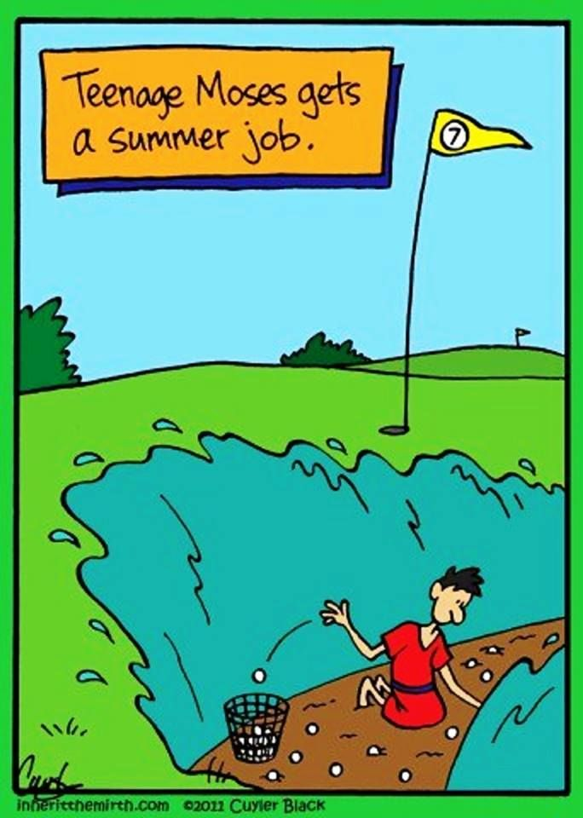
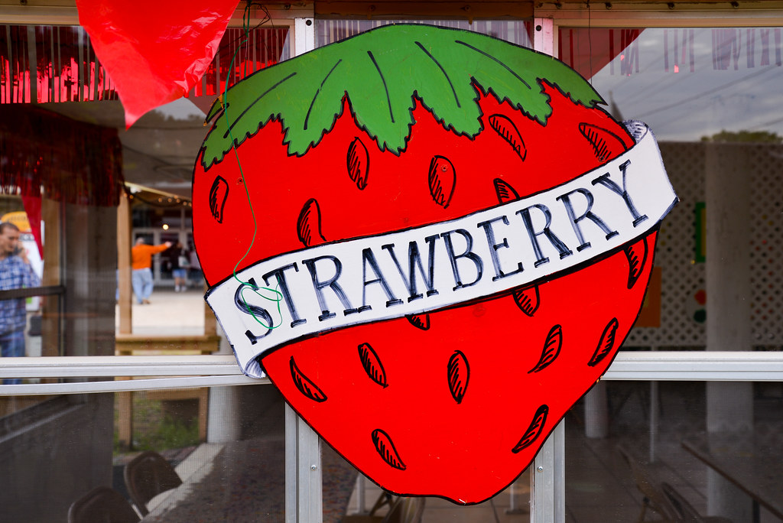

Annual Strawberry Festival
Holy Cross Episcopal Church
4603 Rocks Rd, Street, MD 21154
Mason Dixon Line music! Ice Cream!
Flea Market! Free Kid's Activities!
Pulled Turkey! Raffles! Vendors!
Interested in being a vendor? Contact us at 410-452-5502
Find us on Facebook: @ Holy Cross the Rocks, Episcopal Church

