Holy Cross Winter Newsletter


4603 Rocks Road (Route 24)
Holy Cross Church, P.O. Box 103, Street, MD 21154
.

ot
believe eleven years have gone by so quickly. I have always thought that the happier the times, the faster time goes by. My time at Holy Cross is proof of that.
There is no way I could ever thank each of you for making my ministry at Holy Cross such a wonderful experience. I have so many great memories that I will cherish for as long as I live. No priest has had a better parish. What a blessing you have been in my life.
My husband Al and I want to thank you for welcoming our family whenever they visited. Al will miss all of you as well.
My last service as presider is on September 25th. My final Sunday at the church is on October 2nd. On that day, Bishop Sutton will preside and bless my ministry at Holy Cross that day. I hope you can all be present for both.
I may not be Irish, but this prayer perfectly states my desire for each of you:
May the road rise to meet you.
May the wind be always at your back.
May the sun shine warm upon your face;
And the rains fall soft upon your fields.
And until we meet again,
May God hold you in the palm of His hand.

I will always keep you in my prayers and my heart.
Love and blessings,
Rev. Martie

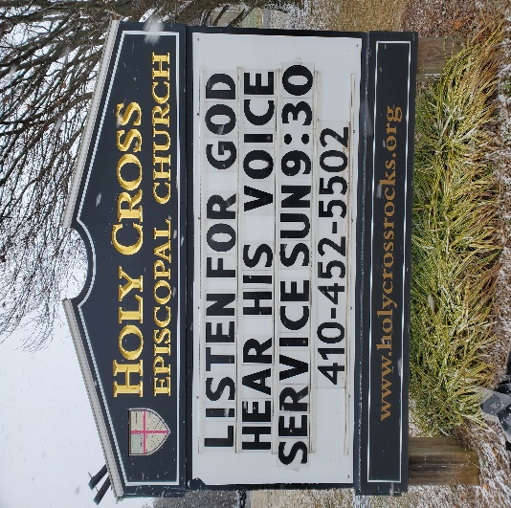

A Note from Rev. Mary: Our 2024 Lent Study topic is “The Way of the Cross.” Here’s what we’re planning for the end of Epiphany, Lent, Holy Week, and Easter:
Sun. 2/11: “Farewell to Alleluia Sunday”! Please bring your kids and grandkids to acolyte and to carry Alleluia streamers (provided by Rev. Mary) in procession. Streamers will be “hidden,” and then Sunday School will meet as usual.
Also, on 2/11—or by 2/14 (Ash Wednesday) at the latest: All are invited to bring in a
cross or photo (preferably 5 by 7 or 8 by 11) of a cross which means a lot to you, with a
couple of sentences of description (in large letters). These will be displayed at coffee
hour on 2/18. If you want me to print out your photo and description, please email them
by Feb. 13 to maryhtdavisson@aol.com or text 443-604-3099.
Ash Wed. 2/14: Rev. Mary will offer Ashes to Go outside from 3 to 5, and Rev. Jan will conduct a service inside at 6.
Sun. 2/18 (Lent I): We hope that a good variety of crosses will be on display during
coffee hour. Rev. Jan will conduct the service but will not offer a formal Lent Study
session because the Advisory Board is meeting.
Sun. 2/25 (Lent II): Rev. Mary will lead our first Lent Study session after the service.
Sun. 3/3 (Lent III): Rev. Jan will lead our second Lent Study session after the service.
Sun. 3/10 (Lent IV): Canon Kristofer Lind-Payne will be our guest clergy and will lead our third Lent Study. (Rev. Mary will also be present as host.)
Sun. 3/17 (Lent V): Rev. Jan will conduct the service but will not lead a Lent Study because of the Advisory Board meeting.
Sun. 3/24 (Palm Sunday): Rev. Jan and Mary will lead the service together. Let’s plan
on good weather and lots of participants to process with palms from outside into the
church!
3/28 (Maundy Thursday): Rev. Mary will lead worship at 6 PM, to include candles and
prayers, handwashing, a simple Eucharist followed by a soup and bread supper, and
the stripping of the altar.
3/29 (Good Friday): Rev. Jan will lead worship at 6 PM, details TBA.
Sun. 3/31 (Easter): Rev. Jan and Rev. Mary will lead the service together. Alleluias will
come out of “hiding.” We hope to see plenty of members and visitors of all ages,
including acolytes! And don’t forget the Easter egg hunt for the children after the service.

A Note from Rev. Jan: Our Maryland Diocesan Bishop – changes!

On Saturday April 27, The Right Reverend Carrie Schofield-Broadbent, or Bishop Carrie as she prefers, will become our Maryland Diocesan Bishop, also known as The Ordinary (the one who ordains.) During a special service at our Cathedral, Bishop Sutton will officially hand over his authority to Bishop Carrie symbolically with the traditional Diocesan crozier (gifted to our brand new Cathedral in 1921) and she will be seated in the Cathedra, the Bishop’s chair. As our Cathedral cannot hold all who might like to attend, the ceremony will be lived-streamed, so watch for further details.
Bishop Sutton has already begun, in a small way, his new role as Senior Pastor for the Chautauqua Institution in New York. He steps into that role full time this summer after retiring as our Diocesan Bishop. In retirement, he and his wife Sonya will reside in their home in Washington DC.
Bishop Carrie, with Bishop’s Sutton’s support, has already called 3 new Canons to the Bishop’s Office, rather than calling an assisting Bishop. As she explained at our regional gathering earlier in January, these 3 priests, along with other senior staff, will augment and support her work as a Bishop, the work of a Diocesan Bishop. She explained that assisting Bishops are typically retired Bishops called to support – and that, for now, one who could be a good fit for Maryland and for Bishop Carrie’s staff is just not around.
All 3 new staff members have been long time colleagues in the Diocese of Maryland. The Rev. Randy Callendar (Canon for Mission), The Rev. Kristin Krantz (Canon for Transitions), and The Rev. Dina vanKlaveren (Canon for Stewardship and Development) join The Rev. Chris McCloud (Canon to the Ordinary for Administration and Mission ) and The Rev. Kristofer Lind-Payne (Canon to the Ordinary for Leadership and Congregational Vitality) as senior staff for the Bishop on behalf of all of us throughout the Diocese. Bishop Carrie emphasized at our meeting that every senior staff member is working to support congregational life and health.
We look forward to a visit from our new Bishop sometime in 2025. In the meantime, we will see our Canon for Congregational Vitality, The Rev. Kristofer Lind-Payne again in March- and no doubt will have a chance to meet some of the other Canons soon.
Other Episcopal changes coming soon: The Most Rev Michael Curry will step down as our Presiding Bishop (chief among our Episcopal Church Bishops) when his 9 year term ends at the General Convention this summer. Already a group of Bishops have been called together by the GC search committee as a discerning group for the election this summer. Please pray for those discerning a call to this 9 year position in leadership for The Episcopal Church, and for Bishop Curry as he finishes up his tenure.
–The Rev. Jan Hamill
For more information check out our Diocesan website www.episcopalmaryland.org
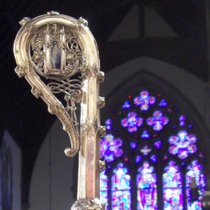

Calendar of Events

February
4 Souper Bowl Free Will donation
11 Shrove Tuesday Sunday Pancake Breakfast
14 Ash Wednesday Ashes to Go 3pm, Church Service 6 pm
18 Advisory Board Meeting
19 Senior Lunch
22 Prayer Book Lenten Series St. Mary's Abingdon 6-8 pm
25 First Lenten Series on The Cross
29 Prayer Book Lenten Series St. Mary's Abingdon 6-8 pm

March
3 Second Lenten Series on The Cross
7 Prayer Book Lenten Series St. Mary's Abingdon 6-8 pm
10 Third Lenten Series: Canon Kristofer Lind-Payne will be our guest clergy and will lead our third Lent Study.
14 Prayer Book Lenten Series St. Mary's Abingdon 6-8 pm
17 Advisory Board meeting
21 Prayer Book Lenten Series St. Mary's Abingdon 6-8 pm
24 Palm Sunday
28 Maundy Thursday
29 Good Friday
31 Easter
April
14 Annual Meeting

May
5 Picnic at Clagget

June 1 Annual Strawberry Festival!!!

Sunday School
This fall we welcomed a few more young people several times. Joan Galbreath’s grandson, the Petersen’s granddaughters, and three of Debbie Rose’s grandchildren. The curriculum currently being used is very flexible, enabling what I hope to be growth. Thank you, Steve, Mary, Debbie, Joan, Shelley and Joe, for bringing the children to Church and letting Holy Cross be a part of their Village.

Holy Cross Guild
This winter (1/14-2/11) the Holy Cross Guild is holding our “Love thy Neighbor” envelope fundraising campaign. This program will raise funds for the Guild’s Outreach Support. This idea originated in the 2013 Horizons Group meeting, (from the Diocese, who visited our church). Prepared are 100 green envelopes prepared with a dollar amount assigned to each from $1.00 - $100.00. Please take one (or two or more) and return as soon as possible. When all envelopes are gathered, $2,500.00 will be raised for the Holy Cross Guild.
The Guild budget process will kick off soon after Easter and be complete in June.
The Holy Cross Guild continues to amaze. Led by Patty W; 24 Seafarer Packages were provided. Led by Carol M we adopted a family with small children and provided an abundance of gifts including clothing and food for dinner plus much more, additionally at the request of Mason Dixon Community Services this year seniors received various home goods and gift cards that were distributed by the mission. We mailed our Christmas packages to all college students and military personnel. This huge endeavor was led by Mary R and Sue B.
Fresh Start Furnishings and Tabitha’s House have also been the recipients of our generosity in the form of housewares and clothing. Additionally, we now have three people volunteering at Fresh Start Furnishings. Walter and Emma Scarborough joined me the third Saturday of every month. Thank you, Walter and Emma.
Green Sale is one of our two sources of monies for outreach. This December we had a great return on efforts. Thanks to all the “elves”,(Sue, Alice, Mary, Karen) who crafted and “jusshed” all the greens. We brought in over $1500 to support all our outreach programs.
.
Thank you for your support of the Delta food pantry, Empty Stocking, and Found in Faith. These groups serve some of the neediest in our own backyard.
Senior Luncheons continues monthly on the third Monday of
each month. Thanks to Mary R and Karen for their great cooking and all the helpers that make this mission work so well.

Senior Warden’s Notes
Galatians 6:9,10
Let us not become weary in doing good, for at the proper time we will reap a harvest if we do not give up. ¹⁰ Therefore, as we have opportunity, let us do good to all people, especially to those who belong to the family of believers.
Our wonderful Angels at Holy Cross continue to amaze me and outperform expectations. Matt and Cathy have been checking up on parishioners that are going through difficult times. We are all praying for them. We continue serving Senior Lunch and without our “Kitchen Angels” we could not offer this service to our community. Thank you all.
The Souper Bowl lunch is scheduled for February 4, 2024, and Shrove Tuesday (Sunday) will be on February 11. This will be our annual Pancake Breakfast Coffee Hour. Both events will ask for a Free Will Offering.
The carpet in the church will be scheduled for cleaning in the spring. We will also be upgrading several of the electric outlets in the church. The thermostat has been repaired and should make the church more comfortable during this cold weather.
Thanks everyone for your generosity, faith, and efforts to keep Holy Cross as a thriving congregation in this community!
God bless,
Chip

